 | Customer Insights · Sprint Review
New insights — Customer Feedback Surveys
Quantitative summary for PMs · Survey feedback batch · n = 166 respondents (CSM 100 + Self-service 66) · 22 Jul 2026

166  Survey responses | 53  With feedback | 40  Insights extracted | 37  Taken forward | 24  Merged into existing | 13  New records (472–484) | 3  Dropped
Database now 377 records (472–484 created in this study) 5 bugs logged to bug list Top reinforced: #102 +10 → 79, #103 +5 → 71, #231 +3 → 15 3 dropped = 2 transient UI-state issues + 1 truncated source
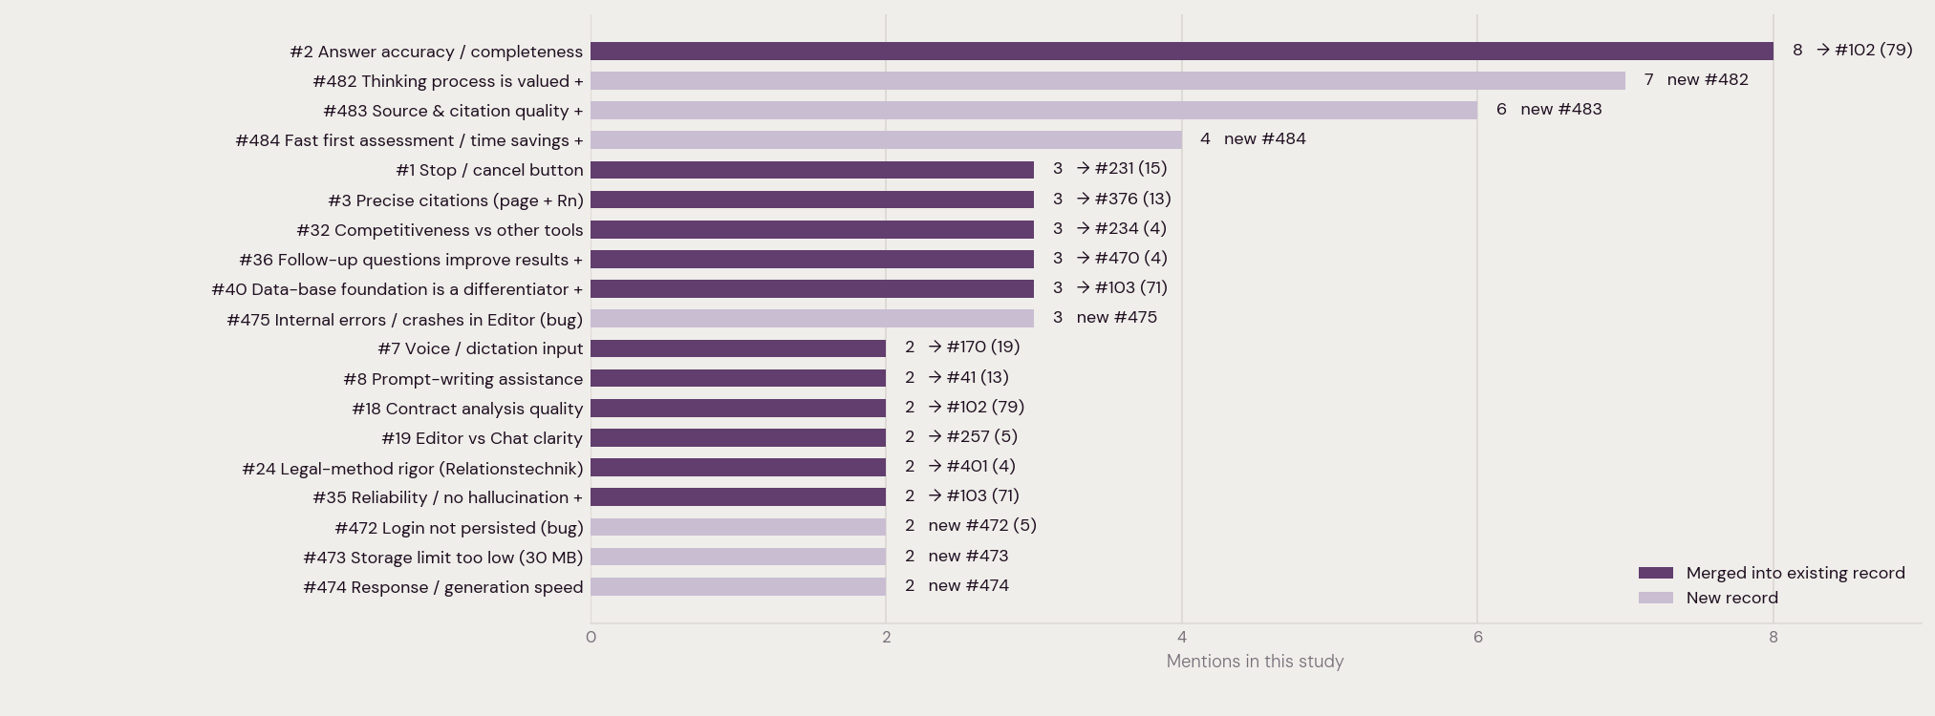
37 insights taken forward, ranked by mentions in this study. Bars show whether each fed an existing database record (with its new running total) or created a new record. · + 18 further insights taken forward at 1 mention each (not charted).

